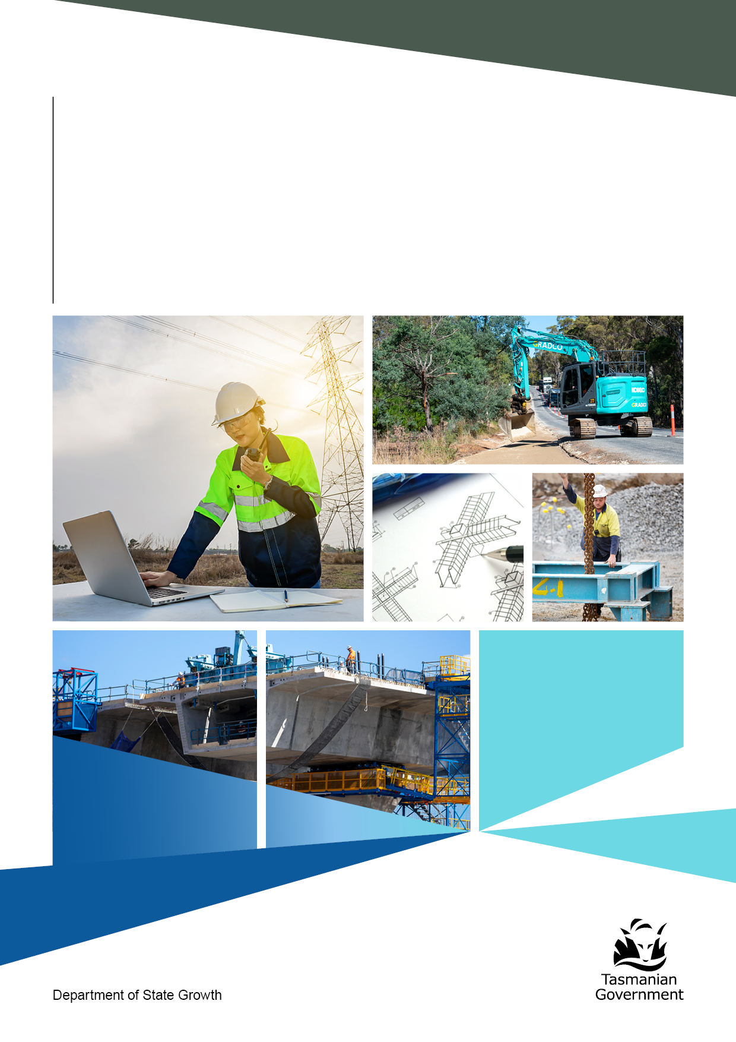

Project Assurance Workbook
Gate 6: Benefits realisation
How well have the project’s purpose, benefits, transition to operations
and lessons been learnt and realised?
September 2024

Document history
Date of issue | Version | Prepared by | Description of changes | Approved by
29 May 2025 | 1.0 | Infrastructure Tasmania | Final – Issued for use | Ben Goodsir, General Manager

Contents
Document history 2
Introduction to project assurance 4
How to use this workbook 4
Project lifecycle 5
Project assurance and agency assurance processes 6
Why do project assurance reviews? 6
Process principles 6
Conducting a review 7
Review ratings 8
PART A: Background on project assurance and the risk based approach 9
Project assurance in Tasmania 10
Risk based approach to project assurance 11
Overview of gate reviews 11
Project assurance review process 12
Review reports 13
SIIRP 14
What does project assurance not do? 14
Roles and responsibilities within a review 15
PART B: Initiating and preparing for a project assurance review 17
How to use part B 18
Assessing if benefits sought have been realised 18
Gate 6 project assurance review and documents 19
Initiating a Gate 6 Review 20
Planning meeting 20
Collaboration 20
Draft and final review report 20
PART C: Conducting a Gate 6 Review 21
Gate 6 approach 22
Gate 6 Review 22
Project assurance review lead 22
Review lead principles and behaviour 23
Review communication protocols 23
Project assurance review report 24
PART D: Gate 6 purpose and report process 25
Gate 6 benefits realisation report 26
Glossary 27

Introduction to project assurance
Project assurance provides independent reviews at key points, or gates, along the lifecycle of a project. These reviews are important for providing confidence to the Tasmanian Government that projects are being delivered on time, to cost and in line with government objectives.
The project assurance framework sets out guidance and minimum requirements for project assurance in Tasmania. Infrastructure Tasmania (ITas) is responsible for administering the framework, which sets out roles and responsibilities for ITas, delivery, and accountable agencies in the process. It is the responsibility of the delivery and accountable agency to meet the framework’s requirements.
Project assurances can consider an individual project, or a program consisting of a number of projects (including sector-specific or place-based programs). For the purposes of this workbook, the use of the term ‘project’ also covers the grouping of projects into a program.
The outcome of each project assurance is a review report. This document will include commentary and recommendations to assist the Senior Responsible Officer (SRO) within the delivery or accountable agency to develop and deliver their projects successfully.

How to use this workbook
At Gate 6, the asset has been commissioned and is in operation. Delivery and/or operating agencies should be able to demonstrate that the project’s purpose, functionality, benefits and transition to operations are complete, or appropriately on track for completion. There should be evidence of a lessons learnt process.
Project assurance workbooks support a consistent, structured approach to reviews, define roles and responsibilities, and assist delivery and accountable agencies, and the review lead to properly prepare for the review process.
Part  A | For agencies and review lead:  - background information on the review process  - information on how the review process applies to projects. | PAGE  9
Part  B | For accountable agencies:  - guidance on how to initiate a review  - documentation required. | PAGE  17
Part  C | For review lead:  - guidance on how to conduct a review. | PAGE  21
Part  D | For accountable agencies and review lead:  - areas for investigation across the seven key focus areas. | PAGE  25

Project lifecycle
The diagram shows the typical gates of a project’s lifecycle where project assurance can be conducted.
 | Activities |  | Gate
Initiate | Establish mandate |  | 0 – Project registration
Initiate | - Decision to initiate project. |  | - Registration with ITas.  - Completion of Gate 0 report template including risk profile assessment and preliminary project assurance plan.
Plan and development | Strategic analysis |  | 1 – Project justification
Plan and development | - Develop strategic case.  - Consider options.  - Conduct investment logic mapping. |  | - Well defined service need.  - Evidence of how the project scope meets the service need.  - Appropriate level of options and  cost-benefit analysis.
Plan and development | Investment decision |  | 2 – Business case
Plan and development | - Identify and appraise options.  - Establish affordability, deliverability and value for money.  - Develop project brief.  - Develop procurement strategy. |  | - Completed business case, including detailed risk plan, cost plan and cost-benefit analysis.
Procurement | Prepare for market |  | 3 – Readiness for market
Procurement | - Specify requirements and finalise procurement documentation. |  | - Scope definition.  - Procurement documentation and commercial approach.  - Evaluation strategy/plan.  - Probity plan.
Procurement | Competitive procurement |  | 4 – Tender evaluation
Procurement | - Release tender.  - Evaluate bids and select supplier.  - Confirm final costings (including contingencies) and update business case. |  | - Evaluation report.  - Probity report.  - Summary of variations.  - Evidence of delivery readiness and handover approach.
Execute | Award contract and delivery |  | 5 – Readiness for service
Execute | - Award contract and commence contract management.  - Construct or deliver asset.  - Establish handover plans.  - Obtain independent verifier report to confirm scope delivery. |  | - Independent verifier reports confirming scope delivery.  - Testing and commissioning documentation.  - Operational readiness documentation.  - Handover strategy.
Close  You are here | Completion |  | 6 – Benefits realisation
Close  You are here | - Confirm purpose and functionality.  - Identify if project on track to meet benefits.  - Report against benefits realisation plan. |  | - Evidence of operational performance.  - Records of lessons learnt.  - Benefits realisation plan.

Project assurance and agency assurance processes
The project assurance process provides recommendations and commentary to assist SROs and accountable agencies to improve projects and assets, with a focus on adding value through the expertise and experience of the review lead.
A project assurance provides an independent snapshot of project status at a point in time. It is not an audit or replacement for an accountable agency’s internal governance. Every Tasmanian Government agency should have its own governance structures and resources in place, to regularly track, report and undertake internal reviews on its portfolio of projects.
Within the project assurance framework, there are 10 different reviews that can be undertaken across the project lifecycle, including specific gate reviews as well as health checks and deep dive processes. Agencies are not expected to undertake every review during the planning and delivery of a project. As part of the project registration process with Infrastructure Tasmania, an appropriate approach to project assurance will be considered in collaboration with agencies.

Why do project assurance reviews?
The Tasmanian Government requires assurance across capital programs that expected services and benefits will be delivered on time, to budget and in line with government objectives. Project issues and risk management should be transparent, with delivery or accountable agencies acting on and mitigating problems before there is an impact on the community and stakeholder outcomes.

Process principles
- The review lead is selected for their skillset and as far as practicable to match the project’s type, needs, stage, scale and complexity.
- The workbook structure and review report template are followed by the review lead.
- All parties focus on value-adding to the project and making themselves available to this critical process.
- Review report commentary and recommendations are focused on practical issues and outcomes.
- All review reports are considered confidential and Senior Responsible Officers are considered the owner of the final report at the finalisation of the review process.

Conducting a review
Step | Activity | Timing
1 | Four-to-eight months from the date of first operations, the accountable agency checks readiness for the Gate 6 Review and contacts ITas. | Planning
2 | ITas and the accountable agency confirm the review dates. | Planning
3 | ITas confirms and appoints the review leader. | Planning
4 | Project planning meeting organised by ITas to formally commence the  review process and provide guidance on how to complete the Gate 6 report template. | Week 1
5 | The acountable agency completes the Gate 6 report template, with input from the asset operator or other appropriate government stakeholders. | Week 2-4
6 | The accountable agencies provide the review lead through ITas with the draft Gate 6 report and supporting documentation. | Week 5
7 | Review lead meets with the accountable agencies to jointly review the draft report and any supporting documents, and to seek any clarification required (including interviews if necessary). | Week 6
8 | Review lead determines the final content of the report, review rating and recommendations prior to submission of the final draft report. | Week 6
9 | Accountable agency fact checks final draft review report and provides responses to the recommendations to ITas, which will liaise with the review lead for finalisation. | Week 7
10 | Post-review survey sent out to accountable agency and review lead by ITas. | Post-review
Project assurance for Gate 6 follows the steps and timeframes shown in the following table.

Review ratings
Overall confidence rating (confidence in successful delivery)
The review lead will assign the project an overall confidence rating:
Low | Successful delivery of the project is in doubt, with major risks or issues apparent in a number of key areas. Urgent additional action is needed. | The project may need re-baselining and/or the overall viability reassessed.
Medium | Successful delivery is feasible but significant issues exist which require timely management attention. | These issues appear resolvable at this stage and, if addressed promptly, should not impact on cost, time or quality
High | Successful delivery of the project to time, cost and quality appears highly likely. | There are no major outstanding issues that at this stage appear to threaten successful delivery.

Individual recommendations (criticality)
Individual recommendations are classified as either critical (red) or essential (amber) as per the diagram below. Green is used for recommendations strengthening good practice.
Critical | Action required. This item is critical and urgent. The project team should take action immediately.
Essential | The recommendation is important but not urgent. The project team should take action before further key decisions are taken.
Good practice | The recommendation is not considered critical or urgent, but the project may benefit from implementing this recommendation.

This ensures recommendations are focused on criticality for project success, while still capturing opportunities to embed good practice across project delivery and leadership.

GATE 6
Project Assurance Workbook

PART A:
Background on project assurance and the risk based approach

For accountable agencies and review lead

Project assurance in Tasmania
The Tasmanian Government has adopted a formal project assurance framework for infrastructure projects valued at $50 million and above, being developed and/or delivered by Tasmanian Government agencies.
Infrastructure projects valued over $10 million can be referred for review at the discretion of Budget Committee, portfolio ministers or heads of agencies.
The framework takes a risk based approach to investor assurance. Each project is assigned one of three risk based project tiers (considering risk criteria as well as the value and profile of the project) and this determines the potential assurance pathway for the project. For projects assessed to have higher risk/profile/value, the assurance pathway prescribes progressively greater levels of scrutiny.
Gate reviews, health checks and deep dives
Gate reviews are short, focused and independent expert reviews held at key points in a project’s lifecycle. They are appraisals of infrastructure projects that highlight risks and issues which, if not addressed, may threaten successful delivery. Gate reviews may be supported by periodic health checks which assist in identifying issues which may emerge between decision points. Deep dives are conducted at any stage of a project’s lifecycle, but focus on a few major issues that have been identified and are based on the terms of reference. Health checks and deep dives, when required, are also carried out by independent expert review teams.
The results of each gate review, health check and deep dive are presented in a review report that provides a snapshot of the project’s progress to strengthen outcomes.
Improving outcomes
Infrastructure Tasmania (ITas) seeks to share aggregated lessons learnt and good practice across delivery agencies, through the interdepartmental Infrastructure Delivery Committee. This has been established to bring together practitioners to share their insight of the development, procurement and delivery of capital infrastructure projects.

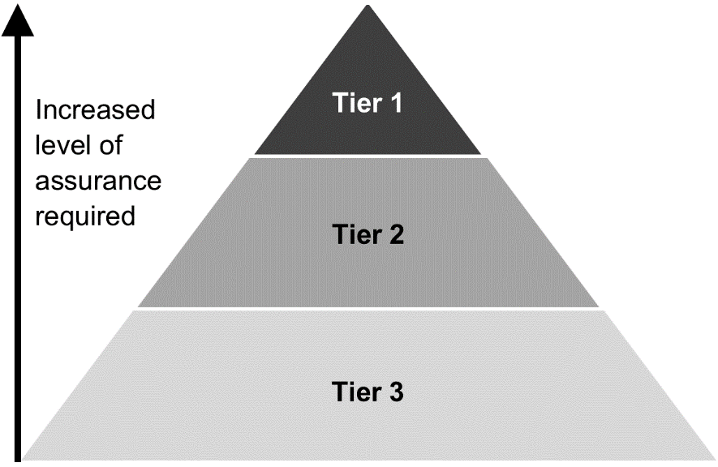
Risk based approach to project assurance
In taking a risk based approach, reviews can be adapted to fit the requirements of all projects.
Registration is mandatory for all capital infrastructure projects with a total estimated cost of $50 million or greater. It is the delivery or accountable agency’s responsibility to register projects.
The risk tier of a project is determined when it is registered with ITas. Projects are assigned a project tier from 1 to 3. Tier 1 is the highest level of risk and therefore greater scrutiny is placed on those projects, with greater frequency of gate reviews, health checks, reporting and project monitoring. The assurance pathway is determined at project registration but may change through discussions between ITas and the delivery or accountable agency.
The objective is to ensure that the appropriate level of attention is given to projects as they are developed and delivered, so that government can optimise community benefits. Agencies are expected to have robust portfolio and program management practices in place, to manage issues and risks for both individual projects and across all capital portfolios.

Overview of gate reviews
Gate reviews are short, focused and independent expert reviews into the progress and direction of a project at key points in its lifecycle. Each of the gates occur at a point within a project phase, timed to inform government decision making and project progression.
Project phase | Lifecycle phase | Gate | Informs
Initiate | Establish mandate | 0 - Project registration | Assess risk and sequence appropriate reviews.
Plan and development | Strategic analysis | 1 - Project justification | Proceeding to develop the business case.
Plan and development | Investment decision | 2 - Business case | The investment decision.
Procurement | Prepare for market | 3 - Readiness for market | Readiness to release procurement documentation.
Procurement | Competitive procurement | 4 - Tender evaluation | Robustness of the evaluation process and readiness to mobilise.
Execute | Award contract and delivery | 5 - Readiness for service | Readiness of the asset to enter service/operations.
Close | Completion | 6 - Benefits realisation | Benefits promised have been delivered.

Project assurance review process
Each gate review has a clear purpose, reflecting the increasing requirement for certainty as a project moves through its lifecycle. Health checks and deep dives are reviews conducted at any point through the project lifecycle. All gate reviews, health checks and deep dives include the involvement of an independent expert reviewer, review team lead and/or review team. These individuals are appointed by ITas based on their independence from the project, experience and expertise.
Gate 0 – Project registration
As project development is at an early stage in the project lifecycle, Gate 0 is the registration process for a project, undertaken by ITas. The Gate 0 report provides an opportunity to consider the project assurance pathway for an individual project.
Gates 1 to 5 – Project development and delivery
Gate reviews are independent expert reviews conducted over a short period. The structure of each of these reviews is similar and focused on high value areas that have greatest impact on successful project development and delivery.
Seven key focus areas support a consistent structure in undertaking reviews and preparing review reports. Review report commentary and recommendations are intended to address the key focus areas, the terms of reference and be constructive in raising issues essential to the project’s success.
Health checks and deep dives
Health checks are similar to gate reviews. They follow the same format to address and rate overall delivery confidence, as well as the seven key focus areas.
Health checks may be conducted at any stage of the project lifecycle but are most likely to be of value when there are long durations between gates. Health checks are useful to identify any emerging issues between key decision points.
Deep dives have limited terms of reference and do not cover the seven key focus areas. Instead, they examine and report on a specific or detailed technical issue(s).
Gate 6 – Benefits realisation
The purpose of the Gate 6 benefits realisation report is firstly to support the close out of the delivery stage, and secondly to assess delivery against the government’s purpose and benefits in choosing to invest in the project. The report is to be finalised 4–8 months from the date of first operations.
Instead of a review team, ITas appoints an independent expert lead reviewer to work with the responsible agencies to complete the Gate 6 report, following a structured template. The most appropriate agency leads the preparation of the initial draft and then the lead reviewer completes the draft content of the report, including the overall rating and recommendations. The lead reviewer then provides the Gate 6 report for review and finalisation.

Review reports
The primary output of any project assurance review is a high-quality written report, which follows the appropriate review report template. For Gate 6, the final draft of the report template, the recommendations and overall review rating are determined by the review lead. The primary purpose of the review report is to inform the accountable agency initial operational status of the asset (following project completion) and key issues impacting functionality and benefits realisation. The accountable agency is expected to act on the recommendations documented in the review report.
Report distribution | - Gate 6 reports are considered the property of the accountable agency and are provided directly to the SRO.  - The review lead must not distribute copies of any versions of review reports directly to accountable agencies, project teams or any other party.  - The review lead sends the draft review report to ITas for distribution.  - The review report must not be distributed outside of the responsible accountable agency until the report is finalised, including agency responses to the review recommendations.  - Copies of final review reports (including agency responses to the review recommendations) are only distributed by ITas in accordance with the protocols outlined in the project assurance framework.  - The final review report must not be distributed to any other parties unless directed by the accountable agency..  - The SRO or accountable agency head may distribute the final review report at their discretion, having regard to the confidential nature of the report.

SIIRP
The Department of Treasury and Finance administers its own review and assessment process for government sector infrastructure investment proposals, called the ‘Structured Infrastructure Investment Review Process’ (SIIRP). Under SIIRP, infrastructure investment proposals are subject to a series of decision points before being considered for funding through the State Budget process and must meet reporting requirements throughout the life of the project.
Given the processes involved with the project assurance framework, the departments of State Growth, and Treasury and Finance maintain regular liaison and collaboration efforts to ensure appropriate alignment between SIIRP and the framework to reduce unnecessary duplication where appropriate.

What does project assurance not do?
A project assurance review is not an audit. The reviews are intended to be confidential and constructive, providing an expert assessment of a project’s status and recommendations to support the successful delivery of the project.
Delivery and accountable agencies should note that reviews will not:
- make an enforceable recommendation to halt a project
- quality check or provide direct detailed assessment of management plans and project team deliverables
- provide a forum for stakeholders or other parties to inappropriately disrupt the direction or nature of a project
- provide a detailed mark-up of management plans and specific project team deliverables
- represent a government decision in relation to funding, planning, approvals or policy.

Roles and responsibilities within a review
The typical roles and responsibilities within a project assurance review are outlined below.
 | Role | Responsibility
Senior Responsible Officer (SRO) | The delivery agency executive (usually the Secretary or Deputy Secretary) with strategic responsibility, who is the single point of overall accountability for project, including responsibility for governance and of benefits. | - Delegate (in writing) appropriate work activities to the project team.  - Endorse the project risk profiling assessment, and agree to the terms of reference, names of interviewees and documents shared with ITas.  - Actively engage with ITas and the assurance review team, including fact checking queries.  - Provide responses to the draft report recommendations.  - Owns and is responsible for addressing or remedying any recommendations in the final report.
Assurance  Review Team | To undertake a gate review, health check or deep dive in line with the agreed terms of reference. | - Undertake a confidential, independent assurance review in line with the terms of reference.  - Write a draft and final report setting out the findings and reasoning for the assurance review and share with ITas and the SRO.
Delivery agency | To develop and/or deliver a project that will undergo a gate review, health check or deep dive. | - Nominate an SRO.  - Make resources available to support successful delivery of the project and assurance reviews.
Infrastructure Tasmania (ITas) | To administer and review the framework. | - Work with delivery agencies to ensure that a project is risk profiled and assigned a risk-based tier rating.  - Establish and administer project assurance panel comprising experts with skills, experience and capability across relevant infrastructure sectors and project delivery.  - Appoint Assurance Review Teams with expertise specific to each project.  - Guide and coordinate the gate review, health check or deep dive.  - Monitor quality, scope and consistency of assurance reviews.  (continued over)  - Provide regular high-level performance reports to agencies and government, including commentary on recommendations, as/if required.  - Collect and analyse data and insights to identify common issues, common themes, data trends and analytics to be included in an annual report.  - Work with agencies, industry and assurance review teams on how to best address challenges at a whole of government level.  - Explore opportunities to share lessons and insights across government agencies and project management communities.  - Maintain and continuously review policy, process and provide advice to government.

Gate 6
Project Assurance Workbook

PART B:
Initiating and preparing for a project assurance review

For accountable agencies

How to use part B
Part B assists accountable agencies to prepare for the project assurance review, including collating documentation and preparing for the project briefing.

Assessing if benefits sought have been realised
Gate 6
Project phase | Close
Lifecycle phase | Completion
Gate review | Benefits realisation
Key question | How well have the benefits outlined in the business case been realised and what lessons can be learnt from this?
Review deliverables | - Evidence of operational performance  - Benefits realsation plan  - Record of lessons learnt
The Gate 6 assesses the project’s purpose, benefits, residual risks from delivery, transition to operation and lessons learnt.
Gate 6 falls within the Close phase of the project’s operation stage. It considers how the project’s benefits have been targeted, measured and realised, and provides an opportunity to reflect on risks and opportunities, in addition to capturing and disseminating lessons learnt.
Timing for Gate 6 is at a point after the asset has been in operation for a timeframe that allows for the demonstration of key benefits. Typically, this may be four to eight months after initial operational commencement. However, the timing of this review should be discussed with Infrastructure Tasmania (ITas) and articulated in the benefits realisation plan.
The accountable agency’s Senior Responsible Officer (SRO) may have changed and the project team may have transitioned. It is therefore important that good quality document management has been put in place and some early preparation and planning for the project’s Gate 6 has occurred.
The Gate 6 Review examines how the benefits sought from the delivery solution and approach have been measured, the effectiveness of project handover to operations, any ongoing risks, opportunities and lessons learnt.
The accountable agency is required to identify, capture and report on key benefits delivered by the project and should be confident of the controls in place to capture benefits through the implementation of the benefits management plan.
Positive outcomes from this review will be achieved if the accountable agency can demonstrate operational results, good functionality and service outcomes, including benefits achieved beyond those in the original business case.
The Gate 6 Review focuses on the transition from the delivery stage into operations, identifying if a project is on track to meet its benefits. It is not assessing whether all the promised benefits have been achieved. As such, the review is held 4–8 months following delivery completion.

Gate 6 project assurance review and documents
The accountable agency is responsible for initiating a project assurance review at the appropriate time. Agencies should seek authorisation as required and the review should be led by the SRO within the accountable agency.
Review leads require evidence that work has been completed, but documentation should not be created solely for a review.
It is intended that accountable agencies use existing project documentation, assistance from the delivery team and asset operator, and not create or customise documents for the review.
At Gate 6, documents should exist that outline the benefits in the business case and how they are being measured and monitored. The lessons learnt from the project should be captured with planning in place to disseminate the findings.
For projects that have only entered initial operations and have further stages of delivery to complete, accountable agencies should attempt to provide the appropriate level of documentation.
Required information to support Gate 6 (if needed, determined by the review lead)
Presentation providing an executive overview of the project, including scope, location and purpose.
Main body of original business case, with any updates made since funding approval.
Close out documentation, including a close out report confirming financial completion.
Benefits realisation plan and register/matrix.
Evidence of a post-completion review, and monitoring of key performance indicators.
Review of final project cost and schedule (including variations) against approved budget and schedule.
Evidence of a lessons learnt review, identifying areas of best practice and potential improvements for the future and an agency plan for dissemination of the key findings.
Evidence to show all delivery stage project risks have been closed out or handed over to the asset owner with appropriate mitigation actions.
Post-operational demand, stakeholder and customer satisfaction, and workforce and organisational impacts.
Identification of any outstanding obligations on the asset owner/operator, including scope elements and planning approval conditions with a plan to resolve/meet any requirements.

Initiating a Gate 6 Review
The accountable agency contacts ITas to initiate the review.
On initiation of the review, ITas will appoint a review lead and conduct a planning meeting. The accountable agency uses this time to draft the Gate 6 Report template. The accountable agency then provides the draft Report to the review lead within three weeks of the planning meeting. This is followed by the review of the report by the review lead and discussions with the accountable agency. The accountable agency and ITas will discuss and agree:
- dates for the planning meeting
- any urgency in the completion of the review report
- any issues to be covered.

Planning meeting
The planning meeting is set up by ITas in coordination with the accountable agency and review lead, to gain an overview of the project and provide guidance on how to complete the report template.
The accountable agency organises the venue and ITas issues diary invitations. The planning meeting may include a site visit if requested by ITas or review lead.

Collaboration
The accountable agency prepares the draft report in collaboration with the asset owner, asset operator and delivery agency (as applicable). The review lead finalises the content of the Gate 6 report and determines the overall review rating and recommendations.

Draft and final review report
The draft report, prepared by the accountable agency, will be issued to the review lead through ITas.
The review lead reviews the report and submits a final draft report and any recommendations to ITas. ITas reviews the final draft report and seeks responses to the recommendations from the accountable agency and SRO, along with any clarifications from the accountable agency or review lead. The report is then finalised.
If deemed required, ITas may appoint an independent review panel to review the report, interview project delivery and operational staff and review/add to the recommendations. Where it is considered appropriate for an independent review panel to be convened, a deep dive terms of reference will be prepared and evidence supporting the review will need to be provided by the accountable agency.

Gate 6
Project Assurance Workbook

PART C:
Conducting a Gate 6 Review

For review lead

Gate 6 approach
The Gate 6 Review is conducted after the initial opening to operations to capture the level of fulfillment of the project’s purpose, benefits, residual risks from delivery, functionality, transition to operations and lessons learnt.
The review lead should use this workbook to guide an assessment of the project against the scope and objectives outlined in the business case and/or benefits realisation plan and provide practical recommendations. The focus is on project delivery objectives, project handover and lessons learnt. The outcome of the Gate 6 review provides an assessment and status of the initial operations of the project and lessons learnt that could enhance future projects.

Gate 6 Review
The Gate 6 Review is structured in four parts: context, handover, lessons learnt and recommendations. The initial draft of the Gate 6 report is completed by the accountable agency and provided to the review lead.
The review lead conducts interviews with the accountable agency and stakeholders (as required) to complete the final draft of the Gate 6 report, writes recommendations and determines the final overall rating for the report.
The gate review includes:
- project documentation is released by the accountable agency to the review lead
- a planning meeting, hosted by the accountable agency, is attended by the review lead, agency Senior Responsible Officer (SRO) and Infrastructure Tasmania (ITas)
- Gate 6 report drafted by the accountable agency in the Gate 6 report template for the review lead to assess
- final draft report completed by the review lead for ITas, including any updates to the content, recommendations and review rating
- finalisation of the Gate 6 report ITas and issue of the report to the SRO.

Project assurance review lead
For the Gate 6 Review, ITas will appoint a review lead with the required mix of skills and expertise. The review lead is expected to work collaboratively with the accountable agency and take responsibility for producing a high-quality written Gate 6 report using the appropriate template.
In the circumstance where ITas determines that a deep dive is required following the finalisation of the Gate 6 review report, ITas will select the review team (typically two to three members).
The review lead and any member of a deep dive review panel must be independent of the project. Reviewers must immediately inform ITas of any potential or current conflict of interest that arises prior to or during the review. This may preclude them and/or their organisation from participating in the project in any capacity.

Review lead principles and behaviour
The review lead is expected to add value to the development and delivery of the project by:
- being helpful and constructive in conducting the review and developing the review report
- being independent, with the review report’s recommendations not directed or influenced by external parties
- adhering to any requirements in the Gate 6 Report template
- providing a review report that clearly highlights substantive issues, their causes and consequences
- providing specific and actionable recommendations.
Project assurance reviews are not adversarial or a detailed assessment of management plans and project team deliverables. ITas requires professional and respectful behaviour during the review.

Review communication protocols
Topic | Details
Report confidentiality | - Review reports are primarily for the consideration and noting of the SRO and delivery agency to support delivery of a successful project, to assist in making decisions about the project or to take action as required.  - All review reports are ultimately owned by the SRO and delivery agency.  - All participants must keep all information, including documentation, confidential.  - Review team members must not directly contact the delivery agency or stakeholders without the permission of ITas.
Report distribution | - Review team members must not distribute copies of any versions of review reports directly to delivery agencies, project teams or any other party.  - The review team leader sends the final draft of the review report to ITas for review and distribution.  - There is no informal element to a review or the review report. A review report is not to distributed without permission of ITas.  - The review team may not keep any copies of any version of the review report, or supporting documents, following submission to ITas.
Review  debrief | - ITas and the review team leader will agree on the process and timing to conduct a review debrief with the delivery agency, following the development of the review report. ITas will liaise with the SRO to approve the agency representatives that attend the debrief.  - There is no informal element to reviews. A debrief to the SRO or any agency executive must not occur without the approval of ITas.
Report  format | - All review reports must include a document control table.  - All review reports must include a list of people interviewed by the review team.  - All versions of reports issued by the review team to ITas are to be in Microsoft Word format.
Report  transmittal | - The delivery agency SRO is the ultimate owner of the final review report and is responsible for document circulation.  - ITas keeps a record of the review report for metrics and trend reporting use only.  - All participants should minimise the use of hard copies of delivery agency documents and review teams must not keep documents in any form following the review.

Project assurance review report
The primary output of a project assurance review is a high-quality written report that is candid and clear, absent of errors and without contradiction and inconsistencies.
The primary purpose of the review report is to provide commentary and recommendations to the accountable agency SRO to support successful project delivery.
The review lead should utilise the appropriate review report template incorporating the review ratings and the review recommendations table.
The Gate 6 Report should be succinct and between 10–15 pages.

Gate 6
Project Assurance Workbook

PART D:
Gate 6 purpose and report process

For accountable agencies and review lead

Gate 6 benefits realisation report
The purpose of the Gate 6 benefits realisation report is to support the close out of the delivery stage into operations, and to assess the successful delivery of the purpose and benefits of the government’s investment in the project.
The Gate 6 report is to be finalised 4–8 months from the date of first operations. The focus is on the project’s purpose, functionality, benefits, residual risks from delivery, transition to operation and lessons learnt.
The report content is to be initially jointly drafted by the delivery agency and asset owner/operator or accountable agency. The drafting is led by the most appropriate agency and must be completed within three weeks of the Gate 6 project briefing, conducted with Infrastructure Tasmania (ITas) and the review lead.
ITas will appoint a review lead to assess the draft report and oversee the completion of the Gate 6 report, including the report’s recommendations and rating. ITas and the review lead will participate in a planning meeting, which the agency will arrange along with any necessary further evidence (documentation), site tour or interviews required by the review lead.
The Gate 6 report is in four parts.
- Project context – a summary of the delivery outcomes of the project to time, cost, scope and benefits
- Project handover – a summary of the status of the handover of the project from delivery into operations
- Lessons learnt – the agency’s reflection on actions taken that impacted outcomes (good and bad).
- Recommendations – actions the agency could take to improve any existing issues or for the future.
While recommendations can be suggested by the agency, it is the review lead that will determine both the final draft report content, review rating and final recommendations.
The report is to be completed in the template provided by ITas.
The report is submitted as final draft to ITas by the review lead. It should be between 10–15 pages. On receipt of the report, ITas will:
- review the report, seek any clarifications required from the review lead, add or clarify recommendations and issue to the agency for fact checking and responses to recommendations
- if deemed appropriate, appoint an independent review panel to conduct a deep dive into the project.
In the instance where an independent review panel is convened by ITas, a deep dive terms of reference will be prepared and the agency will need to support the review.

Glossary
Term | Definition
assurance reviews | Refers to gate review, health checks and deep dives.
Assurance Review Lead | An expert independent reviewer, sourced from the Project Assurance Services Panel engaged by Infrastructure Tasmania to undertake a gate review, health check or deep dive.
deep  dive | Deep dive reviews are similar to health checks but focus on a specific and often technical issue. These reviews are usually undertaken in response to an issue raised by project teams, SROs, Cabinet or the like.
delivery agency | The government agency tasked with developing and/or delivering a project.
gate | Key decision point(s) in a project/program’s lifecycle when a gate review may be undertaken.
gate  review | A review of a project/program by an independent team of experienced practitioners at a specific key decision point (gate) in the project/program lifecycle.  A gate review is a short, focused, independent expert appraisal of the project/program that highlights risks and issues, which if not addressed may threaten successful delivery. It provides a view of the current progress of a project/program and assurance that it can proceed successfully to the next stage if any critical recommendations are addressed.
health  check | A health check is an independent review carried out by a team of experienced practitioners seeking to identify issues in a project/program which may arise between gate reviews.
program | Programs provide an umbrella under which related projects and activities can be coordinated. A program is likely to be longer term and have a life that spans several years.  Projects that form part of a program may be grouped together for a variety of reasons including co-location, similar nature (for example, agency capital program or road upgrades) or shared outcome.  The component parts of a program are usually individual projects or smaller groups of projects (sub-programs). In some cases, these individual projects or sub-programs may have a different project tier to the overall program.
project | A project is a group of interrelated activities that are planned and then executed in a particular sequence to achieve planned and agreed outcomes, within a predetermined timeframe. A particular project may or may not be part of a program. A project has the following characteristics:  • defined scope and finite resources  • has a definable start and end dates  • introduces a change  • creates a unique result, product or service  • has its own governance structure
project assurance | The governance, reporting and independent expert project review process that assesses the health and viability of a project. Project assurance can provide investors and other stakeholders with the confidence that the project can deliver to time, budget and quality.
Project Assurance Services Panel | Established and managed by Infrastructure Tasmania, the panel includes experts with skills, experience and capability across infrastructure sectors and project delivery. The project assurances service panel ensures quick mobilisation and coordination of review teams and the consistent application of the project assurance framework.
project tier | The project tier classification is comprised of three project tiers, where Tier 1 encompasses projects deemed as being the highest risk profile (Tier 1 – high value, high risk projects), and Tier 3 with the lowest risk profile. Tier classification considers a project's overall risk profile and the project’s estimated total budget.
regular infrastructure project reporting | Routine reporting of projects prepared by the Department of Treasury and Finance and provided to government.
Senior Responsible Officer (SRO) | The delivery agency secretary or deputy secretary with strategic responsibility and the single point of overall accountability for a project/program. The Senior Responsible Officer (SRO) is the owner of the business case, accountable for all aspects of governance and delivery of benefits. Some project management methodologies refer to this role as the Project Executive, Sponsor or Client.


Department of State Growth
Level 1, 2 Salamanca Square
Battery Point TAS 7004 Australia
Phone: | 03 6166 3181
Email: | project.assurance@stategrowth.tas.gov.au
Web: | www.infrastructure.tas.gov.au

