
Glenorchy to Hobart CBD Transit Corridor
Transit Corridor Assessment Report – Stage one

Demographic Influences and Travel Patterns

Summary report

July 2012
Department of Infrastructure, Energy and Resources

contentS
contentS 2
1 Key points 3
2 Demographic Influences 4
2.1 Population growth 4
2.2 Population forecasts 4
2.3 Ageing population 5
2.4 Household size 5
3 Housing growth 6
3.1 Residential housing growth 6
3.2 Comparing population and residential housing growth 6
3.3 Infill and Greenfield development growth 6
4 Transport disadvantage 7
4.1 Social Economic Indexes for Areas (SEIFA) 7
4.2 Transport disadvantage 9
4.3 Car ownership 11
5 Travel patterns 11
5.1 Journey to work analysis 11
5.1.1 Journey to work within Greater Hobart 12
5.1.2 Journey to work destinations along the Transit Corridor 12
5.1.3 Modal share along the Transit Corridor 14
5.1.4 Origin of public transport users 15
5.2 Greater Hobart Household Travel Survey Analysis 17
5.2.1 What mode do people use to travel? 17
5.2.2 When do people travel? 17
5.2.3 Why do people travel? 18
5.2.4 What mode do people use to travel for different trip purposes? 19
5.2.5 Where are people travelling to and from? 20

Key points
This report highlights key issues from a demographic and travel pattern perspective in relation to Glenorchy and Hobart City Councils:
- Population growth: Hobart and Glenorchy Councils have different demographic characteristics:
  - Hobart City Council is experiencing medium to high levels of population growth, a trend which is forecast to continue; Hobart is forecast to gain between 8 800 and 16 800 people by 2032 (DCAC 2008). Hobart has a younger age profile than Glenorchy, as it attracts people of working and university age.
  - Glenorchy City Council is experiencing low population growth and is forecast to have static growth into the future; Glenorchy is forecast to have a decrease of 270 people under the ‘medium’ scenario or gain 4100 people under the ‘high’ scenario by 2032 (DCAC 2008). Glenorchy is experiencing demographic change, with an ageing population and high levels of out-migration.
- Household size: Overall household size is decreasing across Tasmania which will create a demand for more housing and diversity of housing types. The greatest concentration of households with one to two residents in Southern Tasmania is found in Hobart and Glenorchy.
- Infill and Greenfield development: If both infill and Greenfield development targets are met in Glenorchy and Hobart, the population could increase well above the population forecast levels. Glenorchy has the potential to experience the greatest population increase because its forecasts are low and it has more Greenfield development opportunities.
- Achieving this level of growth will be a significant challenge, as deliberate planning and policy changes would be required to shift population growth from outer areas towards Glenorchy and Hobart.
- Travel patterns and behaviour: People living in Glenorchy and Hobart have more sustainable travel habits than other areas within Greater Hobart, including greater use of public transport and walking and lower levels of car ownership. This can be attributed to these areas having more compact and mixed use development patterns with a high number of trip attractors.
- High levels of households without a car or only one car: Both Glenorchy (14 percent) and Hobart (12 percent) have high levels of households without a car and around 40 percent of households with only one car (ABS 2006). Not owning a car in these areas is not necessarily a disadvantage, as public transport frequency is high and trip attractors are more likely to be within walking distance.
- Public transport: Suburbs beyond walking distance of the Hobart CBD, have higher levels of public transport use in the journey to work:
- New Town: 9.3 percent.
- West Moonah: 8.5 percent.
- Moonah: 8 percent (ABS 2006).
- Despite using sustainable transport more than other Greater Hobart residents, public transport use is still very low for all trips:
  - Glenorchy: 4.7 percent.
  - Hobart: 2.4 percent (Greater Hobart Household Travel Survey 2008/09).
- Where people do use public transport for different trip purposes, the results are as follows:
  - 14 percent in Hobart and Glenorchy use public transport for education trips.
  - 5 percent in Hobart and Glenorchy use public transport for work trips.
  - 4 percent in Glenorchy and only 1 percent in Hobart use public transport for shopping trips: (Greater Hobart Household Travel Survey 2008/09).

Demographic Influences

Population growth
Population growth creates an increased demand for travel. Growth is occurring in outer urban areas of Hobart’s Northern Suburbs, which will result in additional demand along both arterial road networks.
Brighton Council experienced the highest average annual growth rate of Southern Tasmanian Councils at 2.4 percent from 2001-2008 (ABS 2009). While growth in Brighton is relatively high, it should be noted that this growth is occurring from a small population base, with the population at Brighton being 15 198 people in 2008 (ABS 2009).
In comparison, Glenorchy and Hobart City Councils are experiencing a lower rate of growth, but from a high population base. Hobart is experiencing a higher growth rate than Glenorchy at 0.6 percent, while Glenorchy is only 0.1 percent. In terms of the greatest increase in absolute population numbers, Hobart was the third highest Southern Tasmanian Council, increasing by over 2000 people from 2001-2008, while Glenorchy was less than 500.
Figure 1 Population growth by Councils 2001-2008
Council | 2001 Population | 2008 Population | Average Annual Growth Rate %
Brighton | 12 915 | 15 198 | 2.4
Glenorchy | 44 003 | 44 294 | 0.1
Hobart | 47 446 | 49 577 | 0.6
Source: ABS, 2009.
The pattern of growth of suburbs that feed into the Transit Corridor is variable. The suburbs which have had the biggest growth in absolute population numbers from 1991-2006 include:
- Lenah Valley: 750 people.
- Austins Ferry, Claremont, Berriedale, Montrose, Glenorchy, West Moonah, Mount Stuart, Hobart: 100 to 750 people (ABS 2006).

Population forecasts
From a transport planning perspective it is important to consider population forecasts. The Tasmanian Demographic Change Advisory Council (DCAC) has undertaken population forecasting for Councils based on different population growth scenarios. These forecasts are based on historical growth patterns and do not take into account constraints to significant further residential development, new employment opportunities and the relative attractiveness of locations associated with lifestyle or social status. The medium scenario is based on assumptions that are most similar to recent trends and should be the scenario used for planning purposes.

Figure 2 Population forecasts by Council for High and Medium Scenarios
Local Government Area | 2007 Population | 2020 Population | 2032 Population
Brighton (High) | 14 827 | 20 665 | 26 753
Brighton (Medium) | 14 827 | 19 349 | 24 599
Glenorchy (High) | 44 309 | 46 551 | 48 405
Glenorchy (Medium) | 44 309 | 44 540 | 44 042
Hobart (High) | 49 593 | 58 236 | 66 427
Hobart (Medium) | 49 593 | 54 219 | 58 389
Source: DCAC, 2008.
In 2032, projections indicate that between 9 800 and 11 900 more people will live in Brighton, which is a 65 to 80 percent increase in population. In comparison, growth in Glenorchy is expected to be static, with a small decline forecast under the medium scenario.
Hobart is expected to grow by between 8 800 to 16 800 people, which is more people than Brighton in absolute terms, but at lower percentage growth rate (between 15 to 25 percent).
Glenorchy has low growth forecasts because it has had low growth over the last decade. These low growth rates can be attributed to a high net migration loss. From 2001 to 2006, Glenorchy experienced a net migration loss of 560 persons, the largest net migration loss of all Tasmanian Councils. In comparison, Hobart experienced a net migration gain of 1620 persons, the largest net migration gain of any Tasmanian Council (DCAC 2008).

Ageing population
Tasmania has the oldest population profile in Australia and the population is projected to experience ageing more rapidly than other jurisdications. Changes associated with population ageing will impact on both housing and transport needs. These issues are discussed in more detail in the Problem Identification Report.
Hobart City Council has a younger age profile and is forecast to age less rapidly than Glenorchy:
- Median age: 36.7 years (2006) - fourth lowest in the State and the only Council to record a decline in its median age from 2001 to 2006.
- Population growth from 2001 to 2006 occurred in the 15 to 29 age group and over 45 years.
- In 2007, Hobart had 12.3 percent of its population aged between 18-25, compared to the State average of 7.7 percent.
- Population over 65 is forecast to increase from 13.6 percent in 2007 to 19.1 percent by 2032 (DCAC 2008).
Hobart’s lower median age can be attributed to the attraction of the working and university aged population living within the area.
Glenorchy has an older age profile and is forecast to age more rapidly:
- Median age: 38.7 years (2006) - eight lowest in the State.
- Population growth from 2001 to 2006 occurred in all age groups above 45 years while the population declined in the age groups below 44 years.
- Population over 65 is forecast to increase from 16.8 percent in 2007 to 25.6 percent by 2032 (DCAC 2008).

Household size
The average household size in Glenorchy and Hobart is 2.3 people per dwelling (ABS 2006), which is consistent with the Southern Tasmania average of 2.4 people per dwelling.
Since 1947 the average household size in Tasmania has halved, household size is projected to decrease further to between 2.0 to 2.1 persons per dwelling over the next 20 years (STCA 2010).
Decreasing household size has implications for housing demand, as more dwellings are required even though the population may not be growing at the same rate. Smaller household size also creates a demand for different dwelling types, such as apartments and units.
The greatest concentration of households with one to two residents in Southern Tasmania is found in Hobart and Glenorchy:
- Hobart: 12 682 households.
- Glenorchy: 11 432 households (ABS 2006).

Housing growth

Residential housing growth
Analysis of residential building approvals assists in identifying locational trends for new development and the potential demand for residential land.
From 1999 to 2009, residential building approvals were slightly higher in Glenorchy at 1280 dwellings, with Hobart recording 1091 approvals (ABS 2010). It is interesting to note that despite Glenorchy having higher residential approvals than Hobart, its population growth has been much lower.
Suburbs experiencing the highest number of dwelling approvals were:
- Claremont: 274.
- Glenorchy: 234.
- Austins Ferry: 226.
- Sandy Bay: 177.
- Dynnyrne: 175.
- Lenah Valley: 145.

Comparing population and residential housing growth
Comparing population and residential building approvals can provide an indication of the drivers of residential development, particularly when it is considered against the current average household size.
The average number of new dwellings per person for Hobart Council is close to the average household size at 2.0 people, while Glenorchy is only 0.4 (STCA 2010). As Glenorchy is an inner urban area, it is unlikely to be a location for second homes such as holiday houses, therefore demographic change eg. (ageing population, high levels of out-migration) are more likely to be causes of population change in Glenorchy.

Infill and Greenfield development growth
The Southern Regional Land Use Strategy identifies infill targets over the next 25 years for Hobart and Glenorchy:
- Glenorchy: 40 percent infill (5300 dwellings).
- Hobart: 25 percent infill (3312 dwellings).
These areas have a target density of at least 25 dwellings per hectare (net density).
Based on the current household size in both Glenorchy and Hobart, it can be assumed that if these infill targets are met, that the population in Glenorchy could theoretically increase by an additional 12000 people and in Hobart by 7600.
The population in Glenorchy could further increase if Greenfield areas within the urban growth boundary were developed at Granton and Austins Ferry. The STCA have calculated that the dwelling yield on these Greenfield sites (based on 15 dwellings per hectare) is 2155 dwellings. This would translate to just under 5000 additional people in Glenorchy Greenfield areas.
The actual level of population growth will be dependent on a number of different variables, including availability and uptake of land for infill and Greenfield development and demographic change. As stated above, Glenorchy is experiencing demographic change which has caused low levels of population growth over the last decade.
If infill and Greenfield targets were achieved, together with the ‘medium’ and ‘high’ population forecasts this would result in a total population growth of 17 000 to 21 000 people over the next 25 to 30 years.
Whether this level of growth is achievable is highly debatable, as the increase is around half of Glenorchy’s current population and about half of the forecast population increase for Greater Hobart under the ‘medium’ scenario. Deliberate planning and policy changes would be required to shift population growth from outer Councils towards Glenorchy, if this level of growth was to occur.
It is harder to predict what the additional population growth in Hobart would be if infill development targets were met. Population growth in Hobart is forecast to be high (between 8800 to 16800 people under the medium and high scenarios). It would be expected that most of this growth would be infill as no Greenfield areas were identified in Hobart as part of the Southern Regional Land Use Strategy.

Transport disadvantage

Social Economic Indexes for Areas (SEIFA)
Socio Economic Indices for Areas (SEIFA) is the main indicator of comparative disadvantage used in Australia. SEIFA is a collection of four indexes which compare the relative social and economic conditions of population cross different locations.
Hobart is the least disadvantaged Council in Tasmania, while Glenorchy is the twelfth disadvantaged.
However within Councils there are pockets of disadvantage. The map below shows the most commonly used sub-index of SEIFA which is the Index of Relative Socio-Economic Disadvantage. This index is used to identify areas with high proportions of households with characteristics associated with disadvantage such as low income, low levels of qualifications, unemployment and private dwellings without a car.
Areas adjacent to the Transit Corridor contain areas of high disadvantage around Glenorchy and Moonah and small pockets within North Hobart.

Figure 3 SEIFA – Index of Relative Socio-Economic Disadvantage
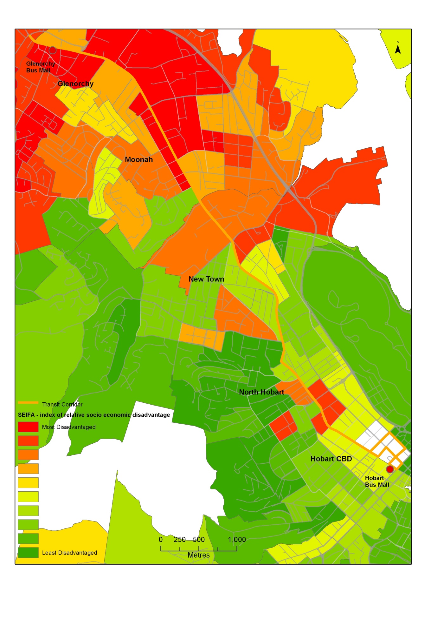
Source: ABS, 2006

Transport disadvantage
SEIFA does not measure transport disadvantage specifically. Transport disadvantage occurs when accessibility and mobility are constrained. Research has identified that age, income and health reduce the ability of people to use, afford and access transport services. A measure of comparative transport disadvantage across Greater Hobart has been prepared for DIER by Booz and Company (2008), based on the following characteristics:
- Adults who do not have access to a car.
- People aged over 60 years.
- People on a disability pension.
- Adults on a low income.
- Adults not in the labour force.
- Young people aged below 17 years.
- People enrolled in an educational institution.
People who are transport-disadvantaged rely primarily on walking, public transport, lifts from taxis and family and friends to meet their needs. Lack of access to transport can affect a person’s sense of wellbeing and quality of life, and can exclude them from participating in work and study opportunities as well as limiting access to services and social networks. These barriers can result in social exclusion.
Figure 4 shows transport disadvantage along the Transit Corridor. Similar to SEIFA, high to very high areas of transport disadvantage occur in Glenorchy and Moonah.

Figure 4 Transport disadvantage
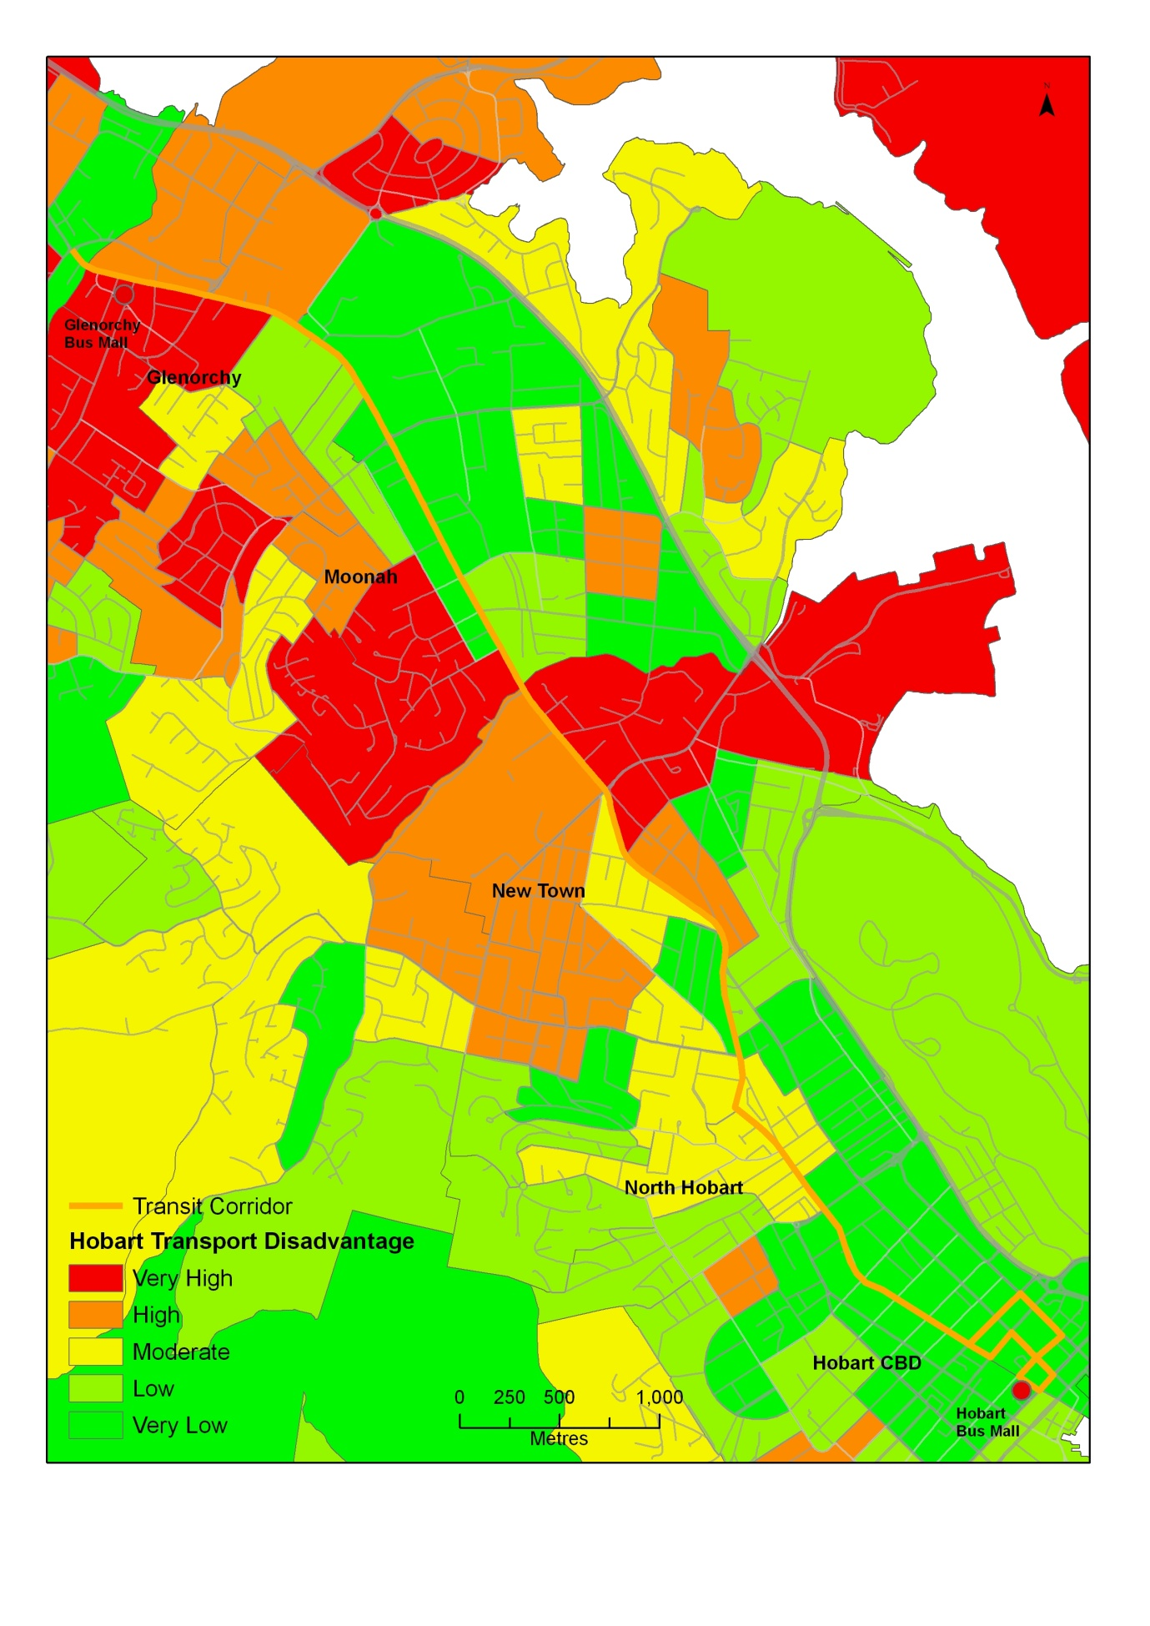
Source: Based on Booz and Company methodology, 2008.

Car ownership
Tasmanians are highly dependent on private cars, with the total number of registered motor vehicles increasing from 350 976 in 2004 to 409 949 in 2010, an increase of 16.8 percent (ABS, 2011). Tasmania has the second highest number of registered motor vehicles per 1000 population, representing 2.6 percent of Australia’s vehicle fleet, but only 2.3 percent of Australia’s total population.
Despite car ownership increasing, there has been a slight decrease in total and average kilometres travelled. From 2005, the average kilometres travelled in Tasmania has decreased from 14 700 to 12 100 in 2010 (ABS, 2011).
Total passenger vehicle kilometres travelled for Hobart, show that there has also been a slight decrease since 2006/07 from 2.24 billion kilometres to 2.18 billion kilometres in 2008/09 (BTRE and BITRE estimates, 2007).
Levels of car ownership also provide an indication of areas which may experience transport disadvantage and therefore have to rely on other modes of transport. In Tasmania, on average, 10 percent of households have no car. Councils with the highest proportions of households not owning a car included Hobart (12 per cent) and Glenorchy (14 percent) (ABS 2006). It is interesting to note that Brighton Council, although experiencing very high levels of disadvantage has a greater proportion of households owning a car. This is largely a reflection of living in an outer urban area with lower densities and fewer suitable bus services which necessitate increased car ownership.
Although households in Hobart and Glenorchy have lower levels of car ownership, these areas are relatively well serviced by public transport and most households are within walking distance of local shops. As people living in inner urban areas are likely to experience greater levels of accessibility, not owning a car is likely to be less of a disadvantage compared to an outer urban area.
The lower levels of household car ownership in inner urban areas, suggests that people are relying on other modes for travel. Increasing the residential density of inner urban areas, which are well serviced by public transport, will mean that some households may opt for only having one car.
Figure 5 Levels of car ownership by household
Council | Households with no cars | Households with 1 car | Lone person households with no car
Glenorchy | 2 361 (14%) | 6 849 (41%) | 1 689 (30%)
Hobart | 2 384 (12%) | 7 985 (42%) | 1 729 (27%)
Brighton | 396 (8%) | 1,518 (33%) | 162 (20%)
Source: ABS, 2006.

Travel patterns

Journey to work analysis
The journey to work often forms the ‘backbone’ of regular travel patterns for many people and usually occurs during peak travel times. However, it should be noted that the journey to work data only captures a proportion of Greater Hobart’s trip patterns; 38 percent of Greater Hobart’s population were recorded as undertaking the journey to work in the 2006 Census.

Journey to work within Greater Hobart
In Greater Hobart, the car dominates the journey to work accounting for 78.8 percent of trips, followed by walking (7.3 percent) and bus (6.1 percent).
Figure 6 Journey to work mode share in Greater Hobart
Mode | Mode share %
Car as driver* | 69.4
Car as passenger* | 9.4
Walked only | 7.3
Bus* | 6.1
Bicycle | 1.1
Source: ABS, 2006.
* note includes two or more methods of journeying to work, therefore figures do not total 100%.
Within Greater Hobart, Hobart City Council is the largest destination of the journey to work, which is indicative of the role of the Hobart CBD as the principal activity centre. Glenorchy is the second highest destination for journey to work, which is largely a reflection of its industrial base. Although Clarence and Kingborough Councils have seen the greatest percentage increase as a destination in the journey to work from 1996 to 2006, these increases are from a relatively low base.

Figure 7 Journey to work key destinations within Greater Hobart
Journey to work destination | 1996 | 2001 | 2006 | Percentage increase from 1996
Hobart | 33 545 | 34 523 | 38 071 | 13.5
Glenorchy | 14 436 | 14 208 | 15 159 | 5.0
Clarence | 7 200 | 7 928 | 9 304 | 29.2
Kingborough | 3 620 | 4 469 | 5 197 | 43.5
Source: ABS, 1996, 2001, 2006

Journey to work destinations along the Transit Corridor
Employment density is also a key driver of public transport demand, as the location of employment is a major determinant of the direction of and demand for peak travel movements. Increasing employment opportunities within activity centres with strong public transport services will increase public transport patronage.
Journey to work data provides an indication of employment numbers along the Transit Corridor. The Transit Corridor contains a number of activity centres and consequently it has a relatively high employment density (total density 42 285 people):
- Hobart CBD (including Battery Point): 26 127 people.
- Glenorchy, Derwent Park and Moonah: 10 652 people.
- New Town, Mount Stuart and North Hobart: 5 506 people (ABS 2006).

Figure 8 Employment density
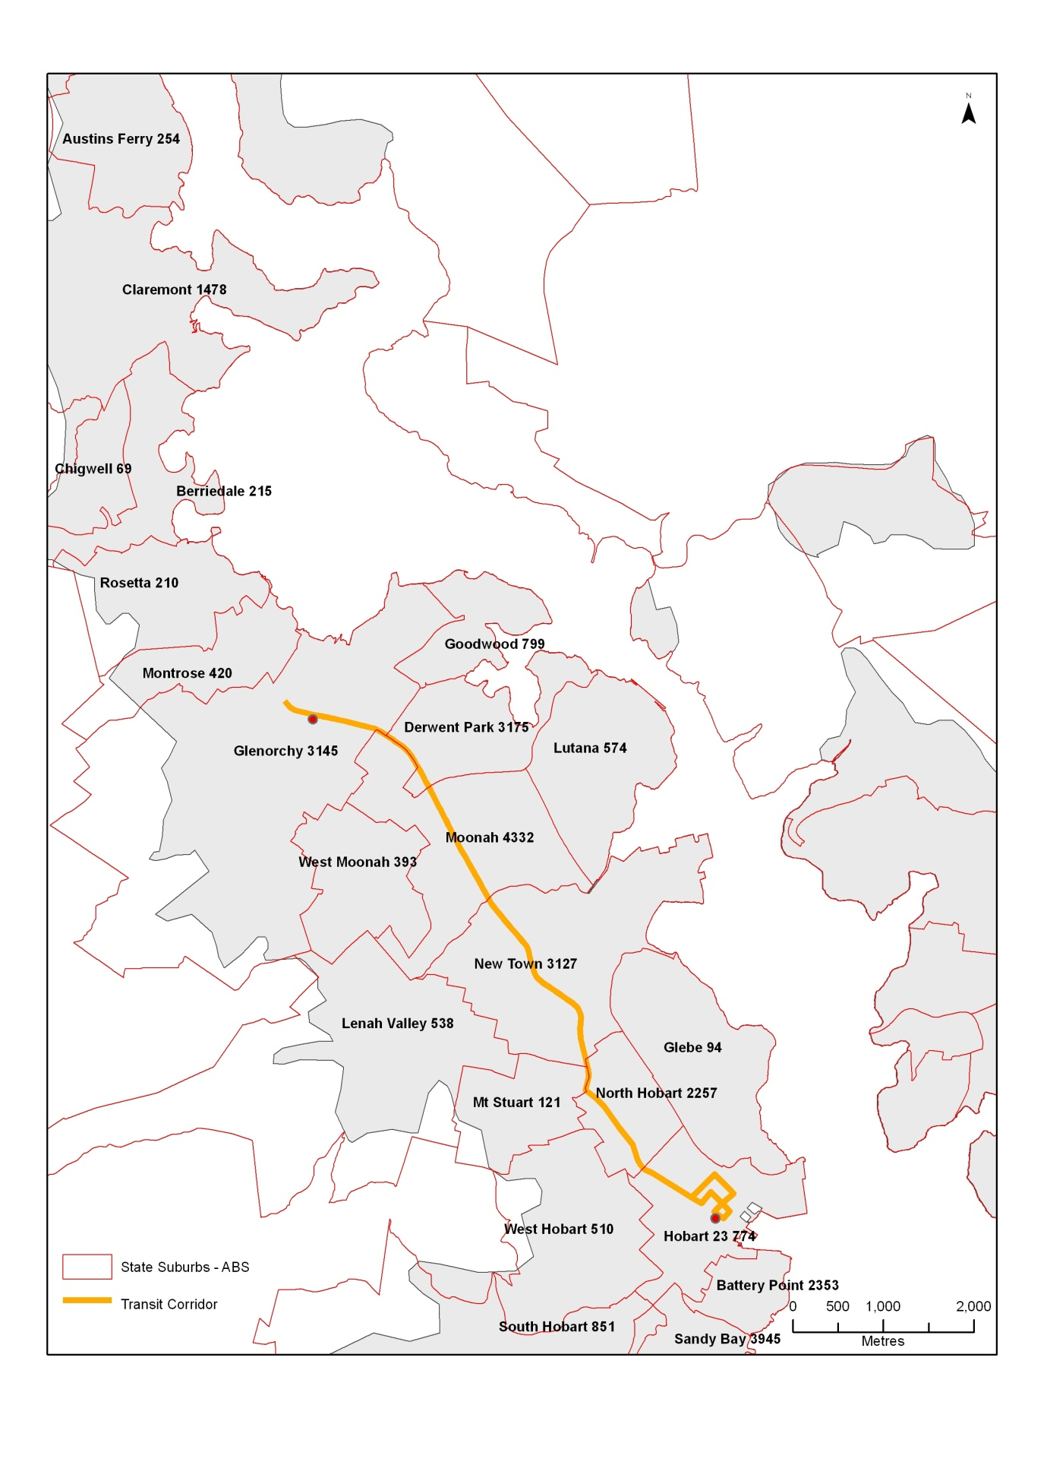
Source: ABS 2006.

When journey to work data is analysed in further detail, 35 percent of people working in the Hobart CBD could use public transport along the Transit Corridor as they either live in a suburb adjacent to the Transit Corridor or live north of the Corridor in suburbs such as Austins Ferry or Claremont.
For people working in Glenorchy, Moonah or Derwent Park, 48 percent of people could use public transport along the Transit Corridor in their journey to work.

Modal share along the Transit Corridor
Car-based travel dominates journey to work trips to key destinations along the Transit Corridor. Walking has the second highest mode share to key destinations along the Transit Corridor, this is because approximately 40 percent of the population in Hobart and Glenorchy live and work locally, making walking a viable transport option.
A greater proportion of people travelling to the Hobart CBD in the journey to work, use public transport than those employed within Glenorchy, Derwent Park and Moonah suburbs.
Figure 9 Journey to work destinations by mode
Journey to work destination | Modal share by bus % | Number of bus passengers | Modal share by walking % | Number of people walking
Hobart CBD (includes Battery Point) | 10.4 | 2714 | 11.32 | 2958
Glenorchy, Derwent Park and Moonah Suburbs | 6.2 | 344 | 7.3 | 404
Source: ABS 2006.
Suburbs close to Hobart CBD have a greater proportion of people walking to work:
- Hobart CBD: 53 percent.
- North Hobart: 37 percent
- West Hobart: 32 percent.
New Town has the highest proportion of people catching a bus at 9.3 percent, followed by West Moonah at 8.5 percent and Moonah at 8 percent. These suburbs are considered beyond a generally acceptable walking distance to the Hobart CBD.
The results show that if people are living in inner suburbs they are more likely to use walking or a bus to get to work. Therefore densification of inner suburbs should lead to increased public transport use and utilisation of more sustainable transport options, such as walking and cycling.
Figure 10 Mode share along Transit Corridor by suburb
Origin | Number of people walking | Percentage of people walking | Number of people catching a bus | Percentage of people catching a bus
Derwent Park | 17 | 7.6 | 4 | 1.8
Glenorchy | 143 | 4.8 | 218 | 7.3
Goodwood | 28 | 10.3 | 18 | 6.6
Hobart CBD | 351 | 52.8 | 26 | 3.9
Lenah Valley | 125 | 5.7 | 162 | 7.4
Lutana | 42 | 5.2 | 68 | 8.4
Moonah | 153 | 9.2 | 132 | 8.0
Mount Stuart | 185 | 16.6 | 51 | 4.6
New Town | 245 | 12.1 | 188 | 9.3
North Hobart | 369 | 37.1 | 62 | 6.2
West Hobart | 739 | 31.6 | 54 | 2.3
West Moonah | 52 | 3.7 | 119 | 8.5
Source ABS, 2006.

Origin of public transport users
Clarence City Council (32 percent) has the highest proportion of public transport users travelling to the Hobart CBD for work than the other Councils, including Hobart itself. This is because a greater proportion of people living within Hobart, walk rather than use public transport to travel to the Hobart CBD.
The major origins of public transport users travelling to Glenorchy, Moonah and Derwent Park suburbs are Glenorchy City Council (33 percent) and Hobart City Council (25 percent).

Figure 11 Proportion of public transport users travelling to Hobart CBD in the journey to work | Figure 12 Proportion of public transport users travelling to Glenorchy, Moonah and Derwent Park in the journey to work
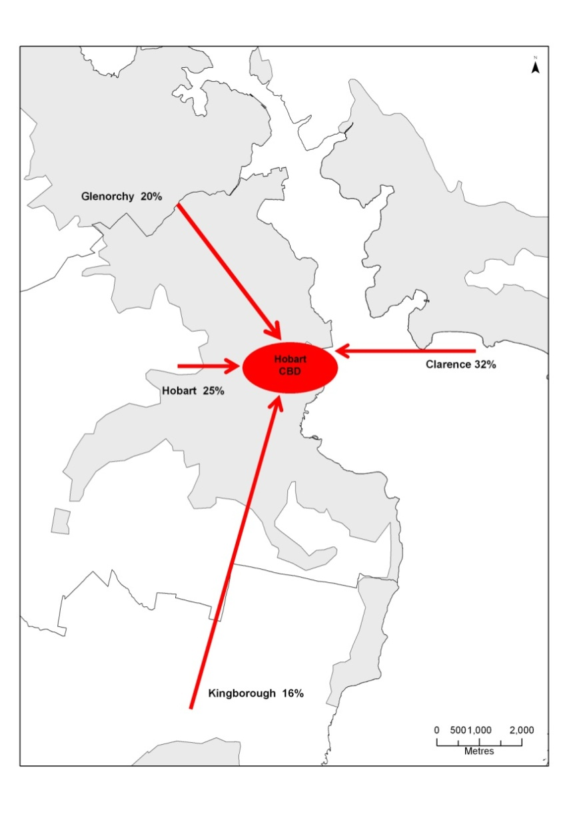  Source: ABS 2006. | 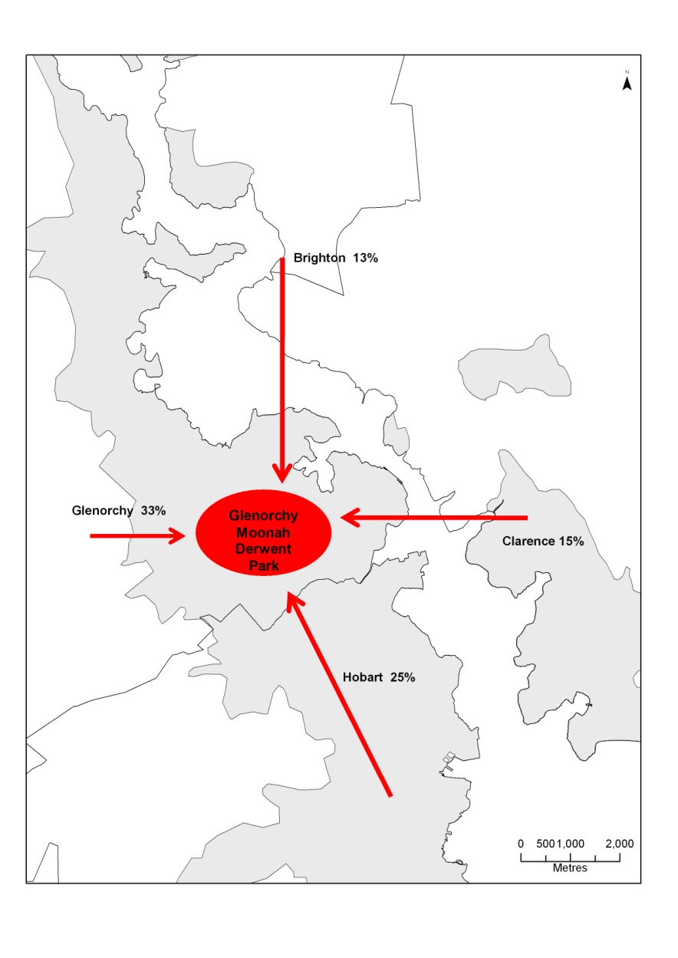

Greater Hobart Household Travel Survey Analysis
The Greater Hobart Household Travel Survey undertaken in 2008/09 provides a detailed account of the population’s typical trip making patterns.

What mode do people use to travel?
Similar to journey to work data, the survey shows that Greater Hobart has low public transport use, at 4.0 percent during weekdays. Public transport has a much lower mode share on weekends, at 1.0 percent in Greater Hobart.
Glenorchy City Council has a higher mode share for public transport than Hobart; however Hobart has a much higher walking mode share at 30.2 percent. Cycling has a low mode share across Greater Hobart at 0.9 percent.
The car is by far the most popular travel mode, although Hobart has the lowest mode share for car trips of all Greater Hobart Councils.
Figure 13 Weekday mode share
Council | Car % | Public transport % | Walking %
Greater Hobart | 74.5 | 4.0 | 20.2
Glenorchy | 75.7 | 4.7 | 17.9
Hobart | 66.0 | 2.4 | 30.2

When do people travel?
Generally, there are a higher numbers of trips undertaken on a typical weekday compared to weekends. On weekdays, the highest number of trips occur in the AM peak, closely followed by the PM peak.
Public transport service frequency is much higher in the AM and PM peak periods to cater for the higher passenger volumes.

Figure 14 Percentage of trips taken at different times of the day (weekdays by hour)

Source: Greater Hobart Household Travel Survey, 2008/09

Why do people travel?
During weekdays, work is the largest proportion of people’s trip making purposes, followed by shopping and recreation and entertainment:
- Hobart City Council:
  - Work: 31.6 percent.
  - Shopping: 19.8 percent.
  - Recreation and entertainment: 20.6 percent.
- Glenorchy City Council:
  - Work: 30.1 percent.
  - Shopping: 22.3 percent.
  - Recreation and entertainment: 14.1 percent.
There is little variation in trip-making purposes between Councils, except more people in Hobart travel for recreation and entertainment purposes.
58 percent of work trips commence in the AM peak, while 74 percent of shopping trips commence during the inter-peak. For Glenorchy residents this shows the importance of the Transit Corridor during the inter-peak for shopping purposes.

What mode do people use to travel for different trip purposes?
A greater percentage of people use public transport to travel to education than for any other trip making purpose:
- Glenorchy: 14 percent.
- Hobart: 14 percent.
Both Glenorchy and Hobart have five percent of people using public transport to travel to work.
Glenorchy has four percent of people using public transport for shopping, while Hobart has only one percent.
Figure 15 Travel mode for trip types, Glenorchy residents (weekdays)

Source: Greater Hobart Household Travel Survey, 2008/09

Figure 16 Travel mode for trip types, Hobart (weekdays)

Source: Greater Hobart Household Travel Survey, 2008/09
When comparing other jurisdictions, capital cities such as Melbourne have a larger public transport modal share than Glenorchy and Hobart for different trip types. Melbourne public transport modal share:
- 19 percent of trips to work.
- 32 percent of trips to education.
Regional cities such as Geelong, have similar patterns to Hobart and Glenorchy. Geelong’s public transport modal share:
- 5 percent of trips to work.
- 24 percent of trips to education (VISTA 2007).

Where are people travelling to and from?
Based on the Greater Hobart Household Travel Survey, 60.5 percent of Glenorchy residents travel within Glenorchy, with Hobart as a secondary destination (21.1 percent), followed by Clarence at 7.5 percent.
Hobart residents have the highest proportion of intra-Council trips for all of Greater Hobart at 66.4 percent. Other key destinations include Glenorchy at 11.6 percent and Clarence at 11.5 percent.
For those residents using public transport, the maps below show the travel patterns as follows:
- 44 percent of Glenorchy residents using public transport, travel internally within Glenorchy, compared to 33 percent of Hobart residents.
- A greater proportion of Glenorchy residents use public transport to travel to Hobart (47 percent).
- Hobart has a higher proportion of people travelling to other destinations such as Clarence (24 percent) and Kingborough (12 percent) than Glenorchy.

Figure 17 Destination of Hobart residents using public transport (weekdays) | Figure 18 Destination of Glenorchy residents using public transport (weekdays)
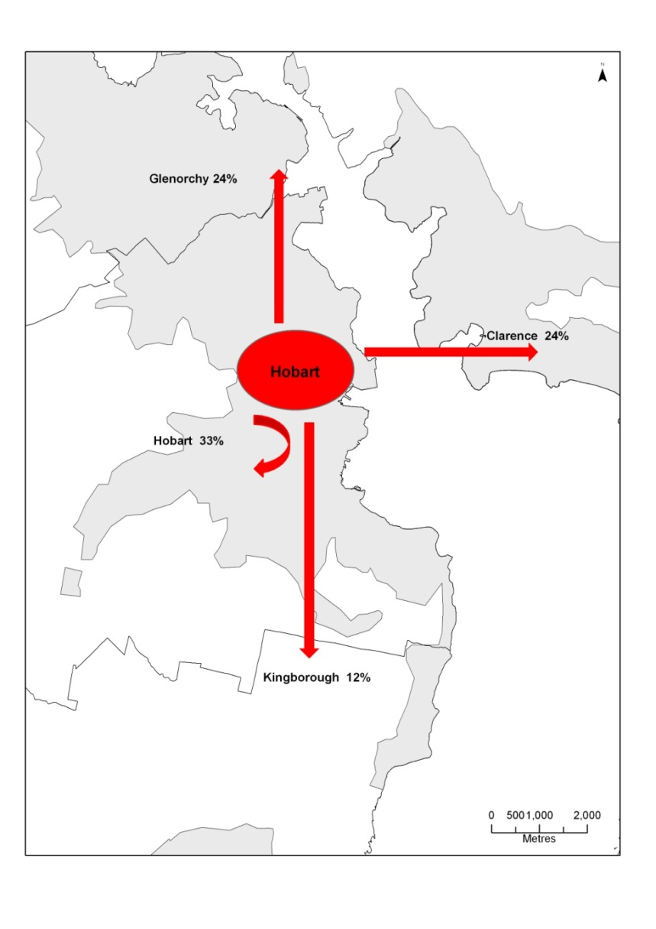  Source: Greater Hobart Household Travel Survey, 2008/09 | 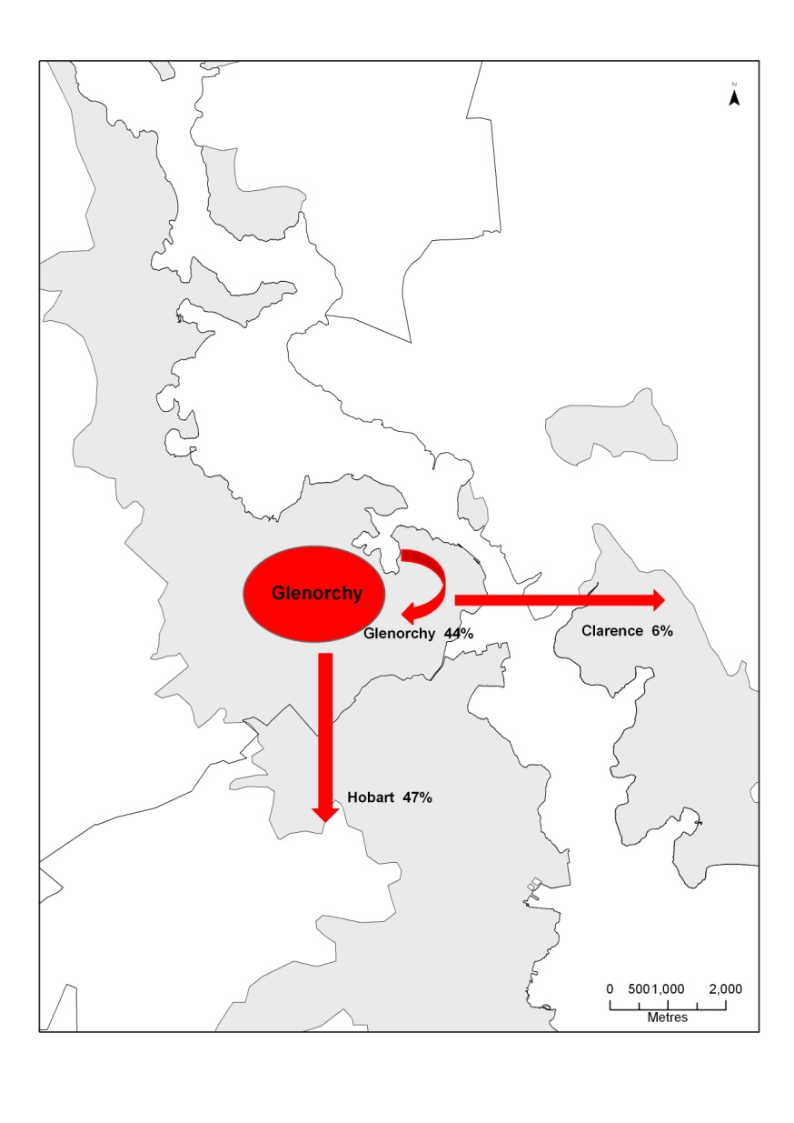



Department of Infrastructure, Energy and Resources

10 Murray Street,
Hobart TAS 7001
Ph: 1300 135 513
Visit: www.dier.tas.gov.au

